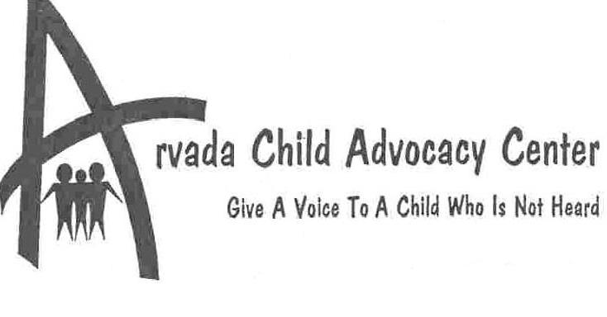

This report is a brief overview of 2003 for the Arvada Child Advocacy Center. The community’s support and generosity continues to further our work with sexually abused children. Throughout the year, the Advocacy Center has received many donations including blankets, stuffed animals, food snacks, candy, videos and financial contributions. The Arvada Child Advocacy Center is part of a wonderful, caring community which is very much aware of urgent issues concerning children and always rises to the occasion to assist wherever possible.

MISSION STATEMENT
The Arvada Child Advocacy Center reduces trauma for sexually abused children throughout the Criminal Justice process.

Our focus is the children we serve. Our desire is to offer a kinder, gentler approach when interviewing your children who are victims of sexual abuse. Our goal is to make these children feel safe and comfortable while at the Advocacy Center. Our hope is we provide the tools and resources to start the healing process and move these children forward into a normal childhood.

Clients visiting the center ranged in age from seven months to teenagers as well as developmentally delayed adults functioning at an adolescent level. The ratio between female victims versus males is approximately 1.75 to 1. The average age of clients is 9 years old.

In 2003, the Center supported 242 investigative interviews; 37 multi-session evaluations; and 53 medical exams, equating to over 400 total visits to the Center.

Eleven agencies requested assistance with their sexual assault cases in 2003. The highest usage was by the Arvada Police Department with 145 children being seen at the Child Advocacy Center. Jefferson County Social Services used the Center
for 33 cases; Westminster Police had 30 cases;

Jefferson County Sheriff’s Office 28 cases; Wheat Ridge Police had 18 and Lakewood Police 10 cases.

The ACAC served 275 children during the year.

The remainder of the cases came from the Golden and Federal Heights Police Departments, and the Jefferson County District Attorney’s Office. Two agencies from outside the metro area also came to the Advocacy Center for services. Gilpin County had four cases and the Colorado Springs Police Department had one case.

The Kars 4 Kids program had a profitable year by raising over $10,000 from donated vehicles that were sold at the car auction. A major component to the success of this program has been the generosity of Connolly’s Towing, who donates car tows to the auction, limiting the Center’s costs.

The Advocacy Center participated in the 10th Annual Pro-AM Cooking Classic in May. The event raised over $10,000 for the center.

The Charity Ball, a black-tie event held Valentine’s Day weekend, raised over $18,000 for the ACAC.

Spirit of Christ Community Generously donated over 100 gifts of crayons, coloring books, games, toys and snacks during the holiday season.

The Child Advocacy Center was selected by 11 high schools throughout the state who participated in the El Pomar Youth in Community grant funding process. The Center received $6,500 total in grants. At the end of the school year, a recognition banquet was held for all the schools and grant recipients.

The Jefferson Kiwanis and members of the business community offer financial assistance through their annual golf tournament.

The Children’s Charity Ball successfully completed its 13th black-tie event on Valentine’s Day weekend by raising over $18,000 for the Child Advocacy Center. The Children’s Charity Ball continues to be the largest, most consistent donor for the Advocacy Center.

The Annual Hero’s party honored over 200 sexually abused children for their completion of their cases through the Advocacy Center’s investigative process and support. Center staff created 100 gift bags and stuffed animals to help recognize these special children.

Dr. Monica Knuesel, the Center’s pediatrician retired after seven years of service. An open house was held to bid her farewell following her last medical exam at the center on December 18th. Dr. Helen Britton will be the new pediatrician beginning in January 2004.

Both Dr. Monica Knuesel and Pat Ahlstrom were recognized for their service to the ACAC by Arvada Police Chief Ron Sloan at an awards ceremony.

Patrick Ahlstrom resigned his board position in May when he accepted the Director of TSA position at Denver International Airport. He was one of the original board members and was the Arvada Police Chief during the development and planning of the Arvada Child Advocacy Center.

